Software Requirements Specification

for

Warehouse Management

Version 1.0 approved

Prepared by Chaitanya Reddy

NIIT UNIVERSITY

14th September 2016

Table of Contents

Table of Contents 2

Revision History 2

1. Introduction 3

1.1 Purpose 3

1.2 Document Conventions 3

1.3 Intended Audience and Reading Suggestions 3

1.4 Product Scope 3

1.5 References 4

2. Overall Description 5

2.1 Product Perspective 2

2.2 Product Functions 2

2.3 User Classes and Characteristics 2

2.4 Operating Environment 2

2.5 Design and Implementation Constraints 2

2.6 User Documentation 2

2.7 Assumptions and Dependencies 3

3. External Interface Requirements 3

3.1 User Interfaces 3

3.2 Hardware Interfaces 3

3.3 Software Interfaces 3

3.4 Communications Interfaces 3

4. System Features 4

4.1 System Feature 1 4

4.2 System Feature 2 (and so on) 4

5. Other Nonfunctional Requirements 4

5.1 Performance Requirements 4

5.2 Safety Requirements 5

5.3 Security Requirements 5

5.4 Software Quality Attributes 5

5.5 Business Rules 5

6. Other Requirements 5

Appendix A: Glossary 5

Appendix B: Analysis Models 5

Appendix C: To Be Determined List 6

Revision History

|  |  |  |  |
| --- | --- | --- | --- |
| **Name** | **Date** | **Reason For Changes** | **Version** |
|  |  |  |  |
|  |  |  |  |

# Introduction

## Purpose

The aim of this document is to explain the detailed description of the Warehouse Management Application. This document will explain all the features, how it will work under different situations and others. Document is intended to make stakeholders and developers to understand the application.

## Document Conventions

Document is written in IEEE Software Requirements Specification format 830.Font sizes, spacing, line gaps are under the same format. Descriptions, requirements and all others of the application mentioned in the document has its own priority and described under its respective section. All the assumptions that are made will be mentioned beforehand and no external assumptions are required.

## Intended Audience and Reading Suggestions

Document is developed for understanding the complete overview of the project. This application that is made will be a industry based project. Developers can make use this document for understanding the use cases, UI flows, requirements and other aspects. Stakeholders, clients and others can use this to understand the use/how to use of the product, features and others. Reading the document in the flow which it is written help to understand the document easily(using the glossary and appendix written in the last when required).

## Product Scope

This product is developed to help in the management of the warehouses online. This application is made up of relational database as a hybrid application which make the application work in any platform without creating a hiccup for the users. This product helps in managing all the products that are existing in any warehouse like, sales reports, purchase reports and others. All the reports and the product statistics will be shown in the graphical way which makes the user to understand his business in no time. Managers, field engineers, developers and many others will be able to check the reports, update of the products and others according their role. The product is developed in a more interactive way so that any type of user even a newbie will be able to understand the flow of the application and use all the features of it. All the mangers/business mans/organizations those are maintaining warehouses will be able to use this product which makes their business flow more efficient and easy way. This product will be help full for the field engineers and other co-workers to get the update about the any product and others details of it at any point of time.

## References

Books: Software Engineering by Roger S Pressman 5th edition, Software Engineering by Pankaj Jalote 4th edition.

Weblinks:https://en.wikipedia.org/wiki/Software_requirements_specification https://drive.google.com/file/d/0B9sPtKJ_1aYrTEQ4cDFnekVmSHc/view?usp=sharing /* UI Flow (from client) */

# Overall Description

## Product Perspective

Warehouse Management application developed for managing all types of warehouses accordingly. This is will be new product under the family of ERP product. Product will be focusing on management of the products that are available in the warehouses. This will be the mainly focusing on the graphical reports.This will be the complete system which includes all the features and covering all the requirements that are required for managing any warehouse without any sub system.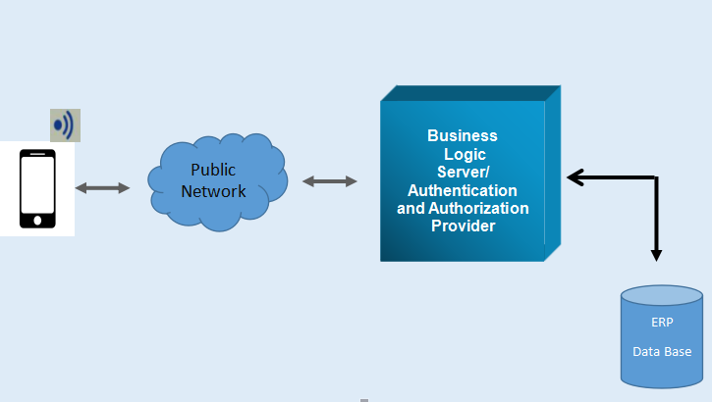

## Product Functions

Functions that a user can perform:

* Purchase Order Creation from Mobile Application
* View List of Purchases Orders
* Delete and Update Purchase Orders
* Sales Order Reports
* Warehouse Management Report

## User Classes and Characteristics

Use case diagram#…..

## Operating Environment

As the system that is being developed is hybrid application same code base will be used to deploy in all the platforms. The framework was made responsive so users of any platform will not face any sort of problem in using the application. So, for each platform different dependencies exists as follows.

Web Application: Any latest browser which is updated is needed. Android Application: Kitkat and above versions are needed. IOS Application: IOS 6 and above will be necessary. Windows Application: Windows Mobile 6 and above will be needed.

## Design and Implementation Constraints

As complete warehouse details will be exsisiting in the database, it should be maintained in a secure server, also the API scripts which connects the application to the database should also be maintained in the secure server. After delivering the product to customer, maintenance will not be taken care by developers. Camel casing is used as programming convention. For CRUD ‘POST’ will be used as communication protocol over HTTPS layer.